

Clinical guidance note: The use of lubricants, vaginal cream, pessaries and other feminine hygiene products in cervical screening

Purpose: To provide guidance on the appropriate use of vaginal products when taking a cervical screening test.

Why use lubricant
Cervical screening can be uncomfortable for many women and painful for some. Using a small amount of lubricant can ease discomfort, reduce anxiety and improve the overall experience.

Which lubricant to use
Use a carbomer-free lubricant.
Products containing carbomers can interfere with the sample and risk producing false-negative and invalid results.

Microscopic comparisons of slide samples

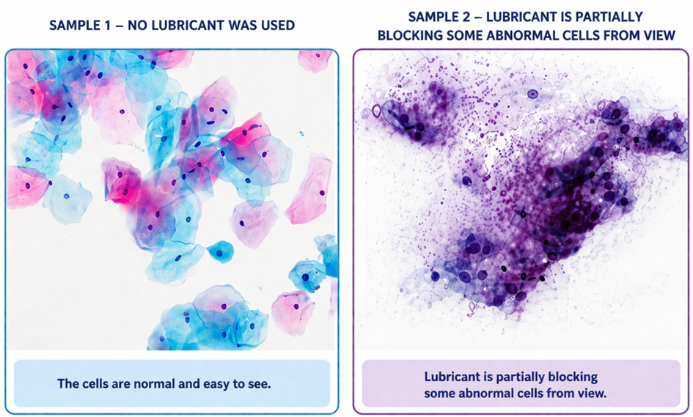

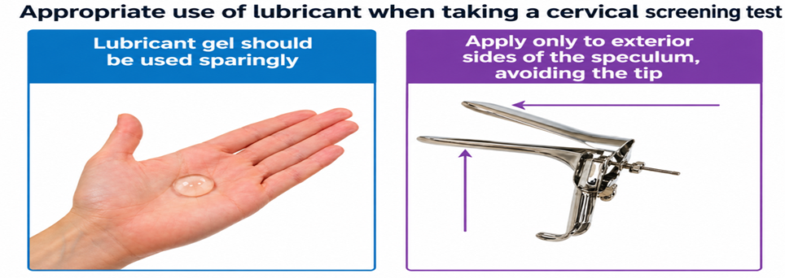

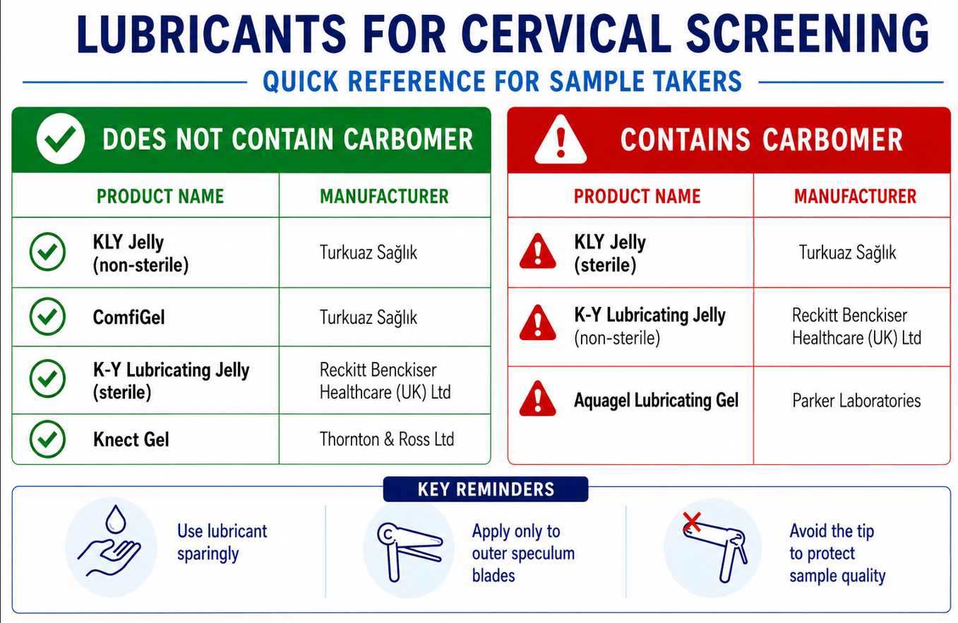

This information is accurate as of April 2026. Given that product formulations may change over time, it is recommended that users verify lubricant ingredients with both the HPRA and the relevant manufacturers on an ongoing basis.

There are other lubricants available. If you are using any lubricant other than the listed products confirmed by the HPRA as of April 2026, you must confirm the lubricant is carbomer free directly with the supplier, manufacturer or HPRA



Do not use water as a lubricant.
Water does not provide adequate lubrication. It evaporates quickly and can increase discomfort for women during the test

Vaginal creams, pessaries, and other feminine hygiene products considerations when taking a cervical screening test

During menopause and post-menopause, reduced oestrogen levels can lead to thinning, dryness, and inflammation of vaginal tissues, a condition known as Genitourinary Syndrome of Menopause (GSM). This may increase discomfort during cervical screening and in some cases, affect sample adequacy.

Vaginal oestrogen can be helpful to alleviate symptoms of GSM and may be prescribed nightly for two weeks, then reduced to 2–3 times per week depending on severity and stopped 2 days prior to sample taking.
There is no restriction on duration of use; it can be continued for years if needed.
NICE guidelines (NG23).

Vaginal oestrogen creams, pessaries and other feminine hygiene products can sometimes affect the accuracy of a cervical screening test.

Sample takers should advise women to stop using vaginal oestrogen or any vaginal creams, pessaries, medicines or moisturisers (lubricant) for 2 days before their screening appointment.

