Laboratory  Sample reception ---►  Test results ---► | Quest Diagnostics  Unit 20 | Northwood Court | Northwood Estate | Santry |  Dublin 9  Tel: 01 609 08 00  Freephone 1800 657 472
Screening kits & forms | Screenlink  Tel: 01 460 52 70  orders@screenlink.net | 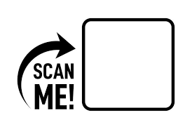  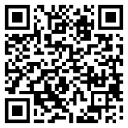  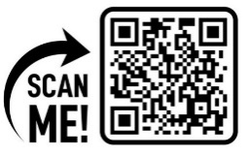
Disposable specula | Distributor: Irish Medical Supplies  Tel: 01 276 1710  sales@irishmedical.ie  www.irishmedicalsupplies.com
Healthlink To register ---►  Enquiries on electronic results ---► | Tel: 01 828 71 15  support.healthlink@hse.ie
Information Brochures  Register to order CervicalCheck information leaflets / brochures | https://www.healthpromotion.ie/ |   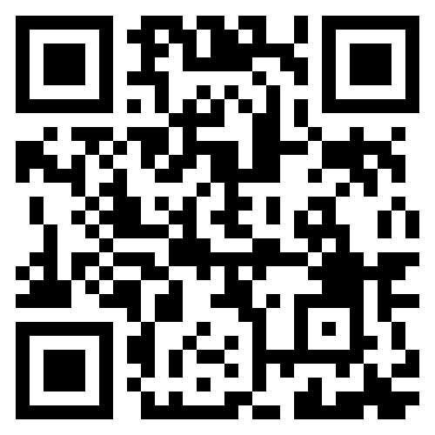
Primary Care Coordination  Support for health professionals in  primary care & secondary care (ex colposcopy) | Tel: 061 406 567 or 061 406 547  primarycarecoordinator@screeningservice.ie
Screening Training Unit  Requests for Training  Tel: 061 406 508 or 061 406 511  stu@cervicalcheck.ie | www.hse.ie/cervicalcheck |   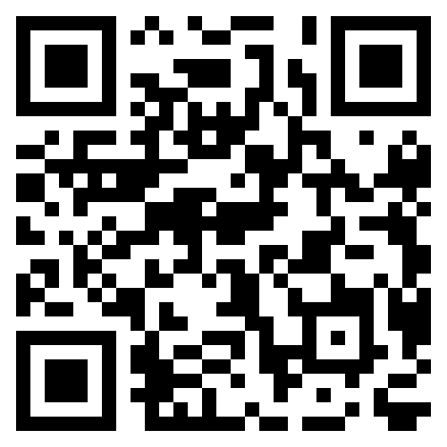
 | www.nssresources.ie
Eligibility  Freephone 1800 45 45 55 or use the online eligibility checker | Online eligibility check | 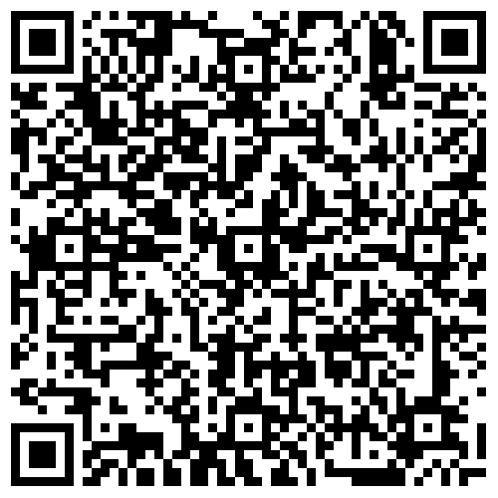
Contracts, Registration & Payments | Administration Office  Tel: 061 406 500  admin@cervicalcheck.ie
Access Officer | access@cervicalcheck.ie

